**BED CA2**

1. Added new endpoint search

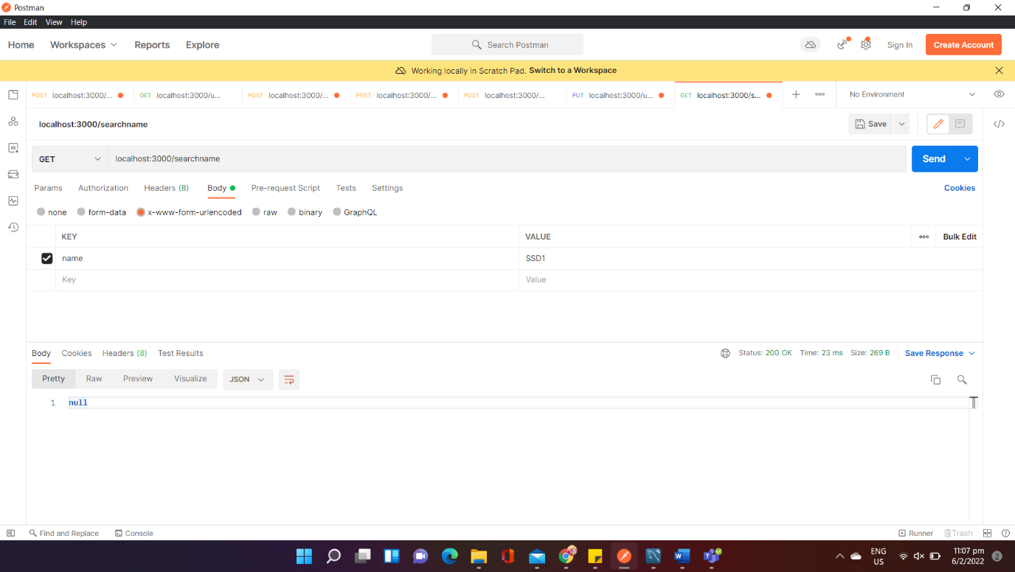

1. Added new endpoint to retrieve product names

